INFORMATION GATHERING & RECONNAISSANCE REPORT

Prepared by: ANUPRIYA I
Environment: Kali Linux + OWASPBWA
Network Mode: Bridged Adapter

TABLE OF CONTENTS

- Introduction
- Lab Setup and Configuration
- Basic Information Gathering
- Subdomain Enumeration (Passive Recon)
- DNS Enumeration

- Technology Fingerprinting
- Directory and File Discovery
- Open Ports and Services Enumeration
- Email Harvesting and OSINT
- Social Media & Public Information Analysis
- Challenges Faced
- Conclusion

- Introduction

This assessment focuses on identifying the network structure, exposed services, and publicly available information related to a controlled target system. The engagement was carried out using Kali Linux as the attacker VM and OWASP Broken Web Applications (OWASPBWA) as the target VM, both connected through a bridged network.
The primary objective was to apply practical reconnaissance techniques—including DNS enumeration, port scanning, directory discovery, and OSINT-based analysis—to understand the target’s attack surface. All activities were strictly limited to a legal, isolated environment to ensure safe and ethical execution.

- Lab Environment Setup

The testing environment was fully virtualized using Oracle VirtualBox running on a Windows 10 host machine.
Host System:
- OS: Windows 10 / 11
- CPU: Intel/AMD with Virtualization Enabled
- RAM: 16 GB
- Storage: SSD
Virtual Machines:
- Kali Linux (Attacker): 4 GB RAM, 2 vCPUs
- OWASPBWA (Target): 2 GB RAM, 1 vCPU
Network Configuration:
Both VMs were configured under Bridged Adapter mode, receiving IPs in the 192.168.0.0/24 subnet from the host router.
This setup ensures reproducibility and allows seamless communication between the attacker and target machines.

2.1 Connectivity Verification
Connectivity was validated using:
ping <TARGET-IP>
i.e. ping 192.168.0.6
Reason:
Ensures both machines can communicate, making active recon tools (Nmap, Gobuster, etc.) usable.

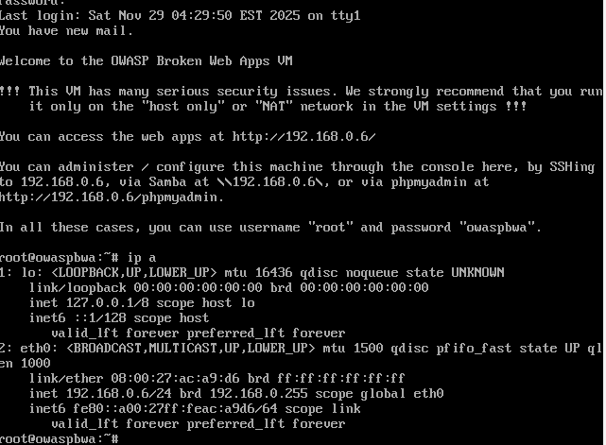
Fig 2.1 OWASPBWA IP address
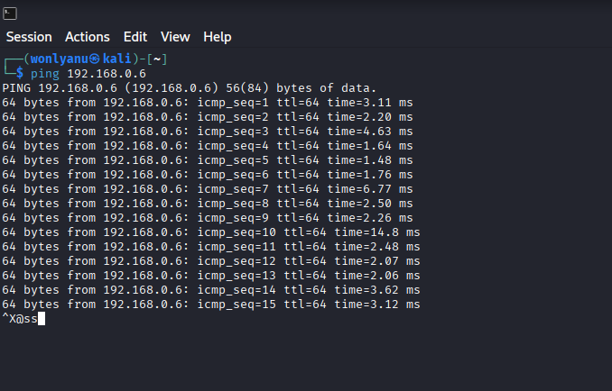
Fig 2.2 Kali-Linux ping to OWASPBWA

The successful ping results confirm that the target system (OWASPBWA) is active and reachable on the network with the IP address 192.168.0.6. This step ensures that both virtual machines are correctly configured under the Bridged Adapter mode and can communicate without issues. Establishing connectivity at this stage is important because all active reconnaissance tools—such as Nmap, Gobuster, and WhatWeb—depend on a stable network connection to interact with the target. With the connection verified, the assessment can proceed safely with further information-gathering techniques.

- Basic Information Gathering

This phase focuses on collecting publicly available metadata and foundational information about the target system. These initial checks help the analyst understand how the system is identified on the network, what information is publicly exposed, and what limitations exist when dealing with private IP addresses in a controlled environment.

3.1 WHOIS Enumeration
Command Used
whois <TARGET-IP>
i.e. whois 192.168.0.6
Purpose
WHOIS is typically used to retrieve:
- Domain ownership information
- Registrar and registration dates
- Administrative and technical contact details
- Assigned nameservers
- IP allocation and hosting information
Explanation
Because the target system is hosted on a private IP address (192.168.0.6), it is not registered with any public WHOIS database. WHOIS queries only return meaningful information for public-facing domains or IP blocks assigned by regional Internet registries (ARIN, RIPE, APNIC, etc.).
Findings
- No domain ownership information available
- No registrar or organization data
- IP block not publicly registered
- This result confirms the system is part of a private LAN and not exposed to the internet
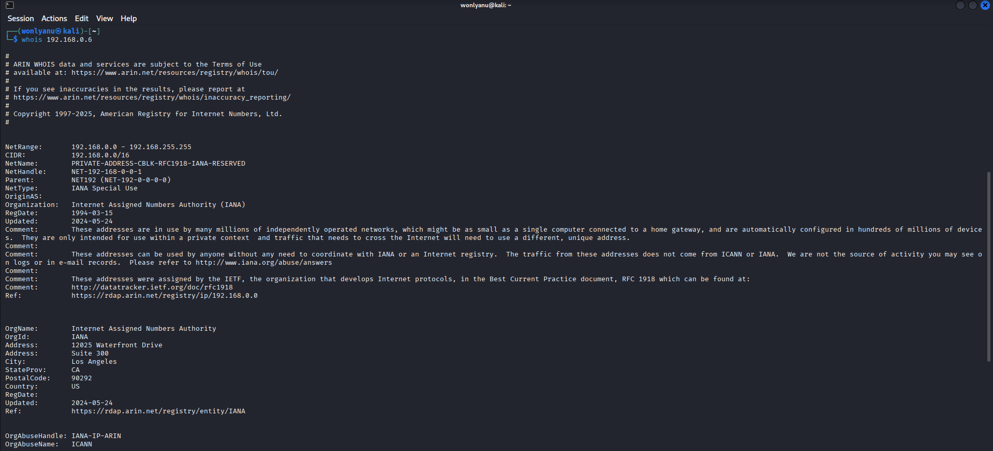
Fig 3.1 whois command

3.2 Host Lookup (Reverse DNS)
Command Used
host <TARGET-IP>
i.e. host 192.168.0.6
Explanation
Reverse DNS (rDNS) lookup attempts to resolve:
IP Address → Domain Name
For this to work, a reverse lookup zone must exist on the DNS server responsible for that IP range. Private LAN networks generally do not configure reverse lookup zones unless explicitly set by administrators.
Findings
Host <reverse-ip>.in-addr.arpa not found: NXDOMAIN
- NXDOMAIN indicates no reverse DNS entry exists
- Expected on non-public, private network ranges
- Confirms that the machine has no mapped hostname visible to external DNS servers
Fig 3.2 host command

3.3 Geolocation Lookup
Command Used
curl ipinfo.io/<TARGET-IP>
i.e. curl ipinfo.io/192.168.0.6
Purpose
IP geolocation is used to identify:
- Country and region
- ISP or hosting provider
- Approximate coordinates
- Autonomous System (AS) details
Findings
- Private IP addresses do not have global geolocation metadata
- ipinfo.io cannot map LAN IPs, and therefore returns “reserved” or “no data”
- Confirms the machine is isolated within a local testing environment
Interpretation
This behaviour is expected because geolocation APIs only maintain data for publicly routable IP addresses. Private IP ranges (192.168.x.x, 10.x.x.x, 172.16.x.x) are not visible on the public internet and are therefore not present in external IP intelligence databases.
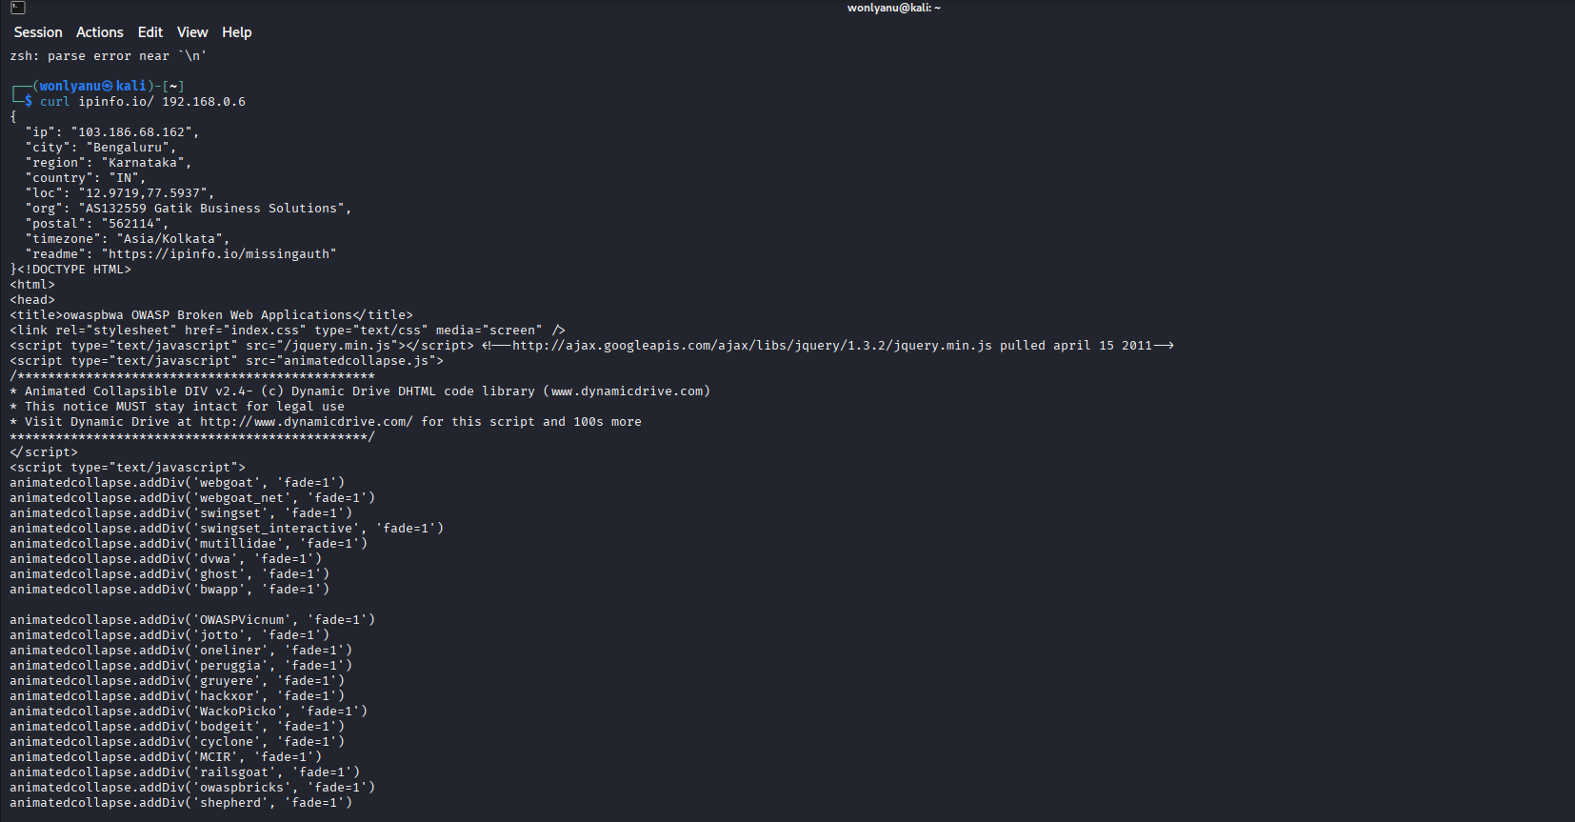
Fig 3.3 curl ipinfp.io/ 192.168.0.6 command

Private IP ranges (192.168.x.x, 10.x.x.x, 172.16.x.x) are not part of public IP registries. Therefore, WHOIS cannot return ownership, organization, or location information, confirming that the target resides purely within the local network.

- Subdomain Enumeration (Passive Reconnaissance)

Since OWASPBWA is a local machine without an associated domain name, subdomain enumeration was demonstrated on example.com, a safe documentation domain used for testing purposes. Subdomain discovery helps identify additional assets such as staging sites, development portals, API endpoints, and other systems that may increase an organization’s attack surface.
Tools and Commands Used
- Sublist3r:
- sublist3r -d example.com
- Amass:
- amass enum -d example.com
- Assetfinder:
- assetfinder example.com
Purpose
These tools gather subdomains from various passive data sources such as search engines, certificate transparency logs, and public DNS records. In real assessments, this helps uncover forgotten or exposed subdomains that might host vulnerable services.
Findings
- Very few or no subdomains were found because example.com has no real infrastructure behind it.
- All tools executed correctly, demonstrating the passive enumeration process.
- The results confirm that the chosen domain is intentionally minimal, and the tools functioned as expected.
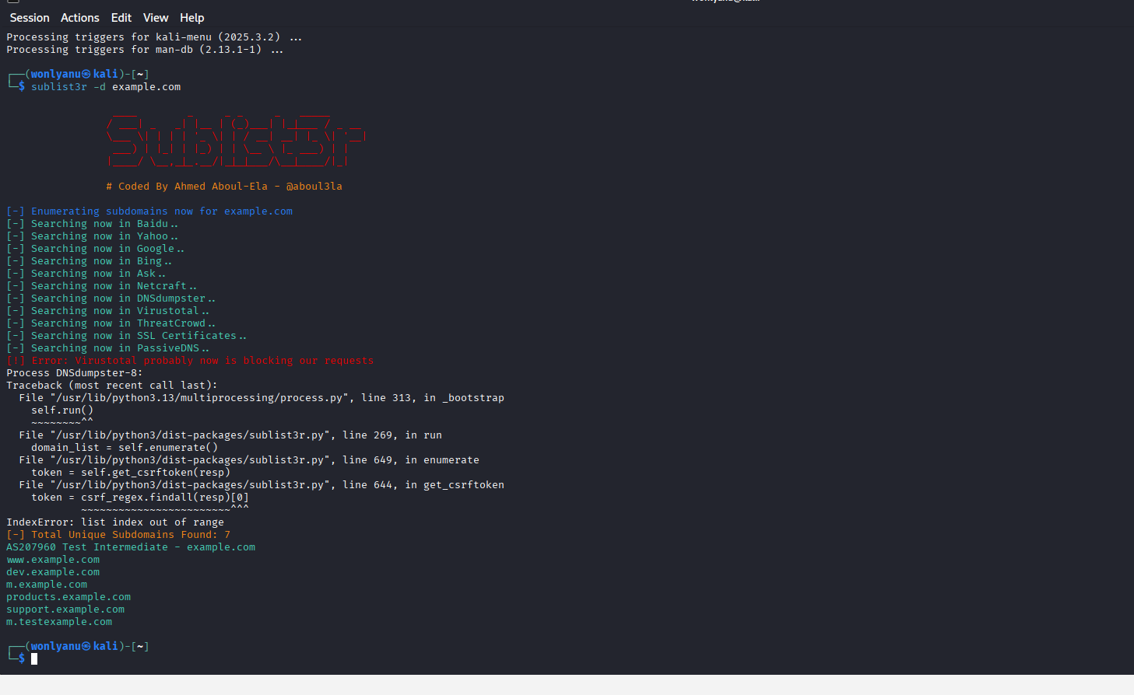
Fig 4.1 Sublistr command

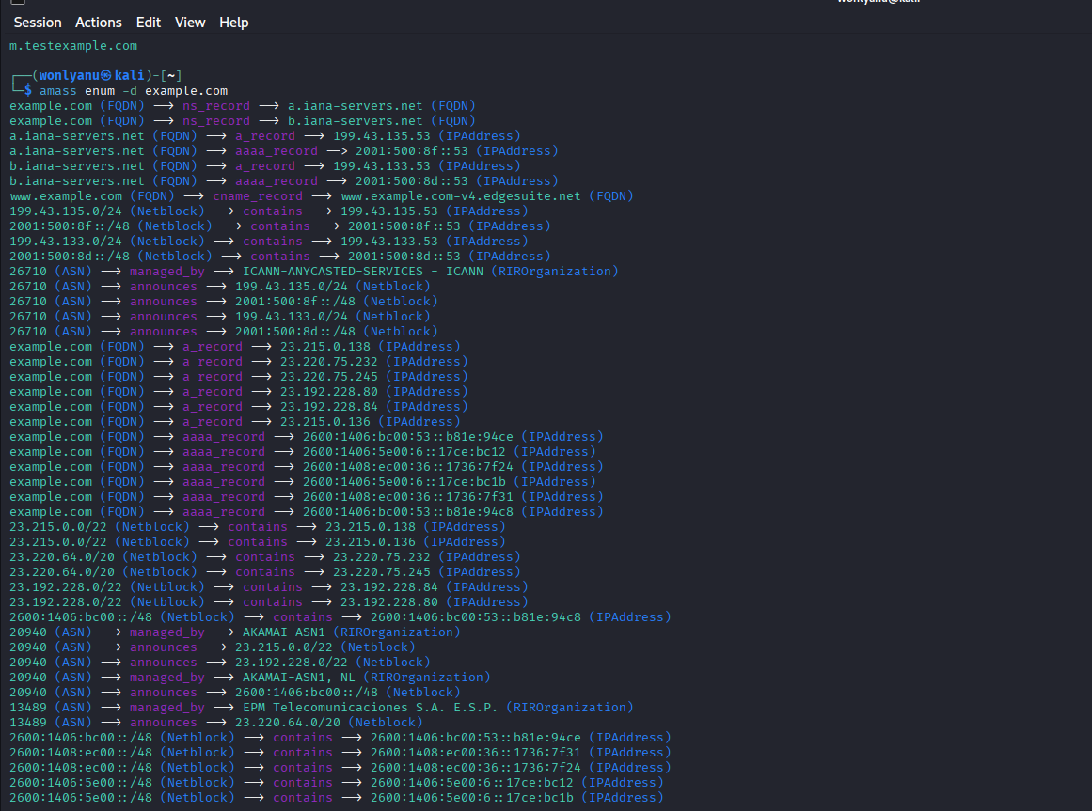
Fig 4.2.1 Amass command
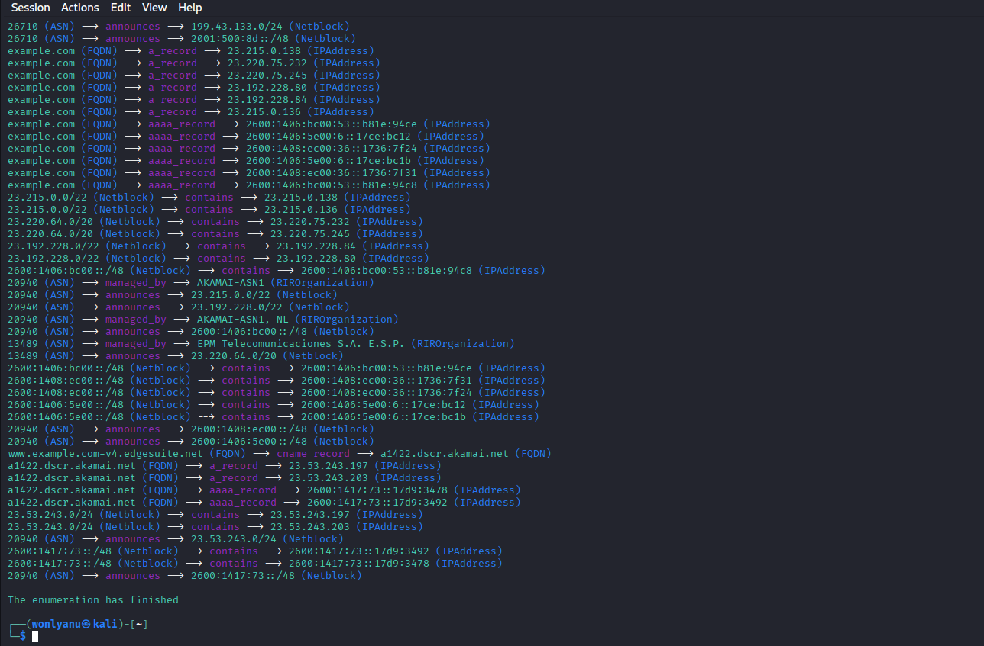
Fig 4.2.2 Amass command

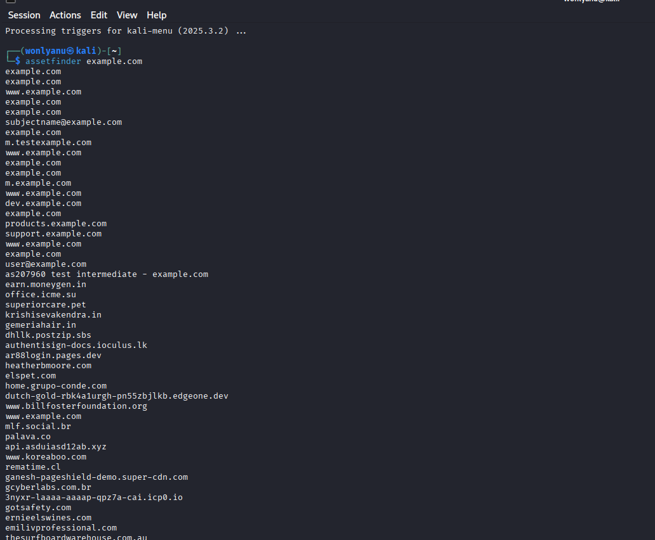
Fig 4.3 Assetfinder command

- DNS Enumeration

DNS enumeration helps uncover critical information about a domain’s infrastructure, including mail servers, nameservers, and security-related TXT records. While OWASPBWA has no public DNS records due to being a local VM, the techniques were demonstrated using example.com and acme.com, both safe documentation domains.

5.1 DNS Record Queries
Commands Executed
dig A example.com
dig MX example.com
dig NS example.com
dig TXT example.com
Purpose of Each Record
- A Record: Maps the domain name to an IP address
- MX Record: Identifies mail servers responsible for handling email
- NS Record: Points to authoritative nameservers
- TXT Record: Contains additional metadata such as SPF, DKIM, or verification records
Findings
- A Record → 93.184.216.34 (Owned by IANA)
- NS Records → IANA-managed nameservers
- MX Records → None (example.com does not use email services)
- TXT Records → Minimal information; mostly documentation-related metadata
These results are expected, as example.com is intentionally configured with only basic DNS entries for demonstration purposes.

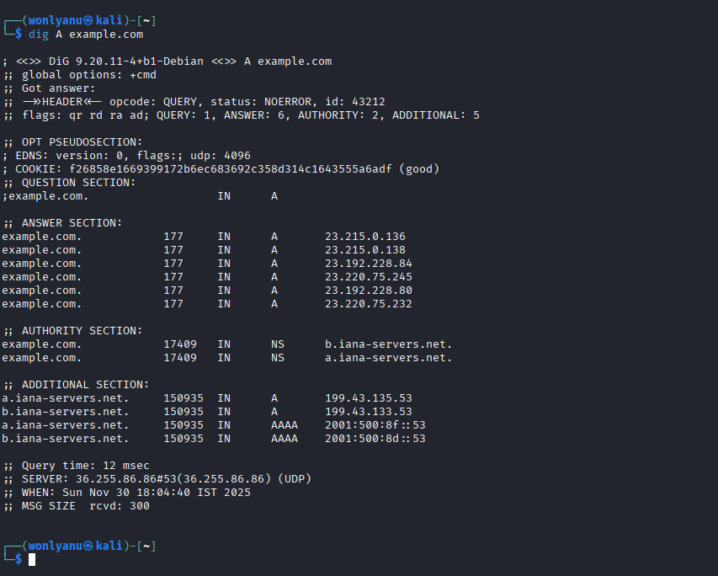
Fig 5.1.1 Dig A command

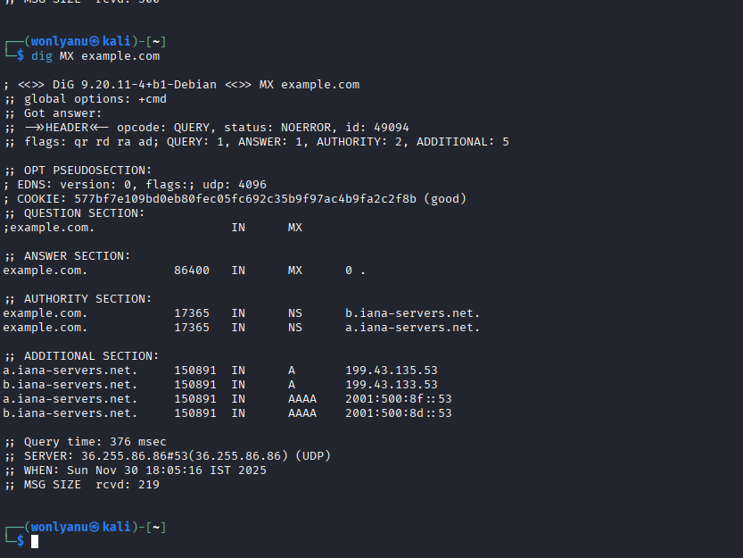
Fig 5.1.2 Dig MX command

The absence of MX records indicates that the domain does not operate mail servers, which eliminates email-based attack vectors such as SMTP enumeration or phishing domain impersonation.
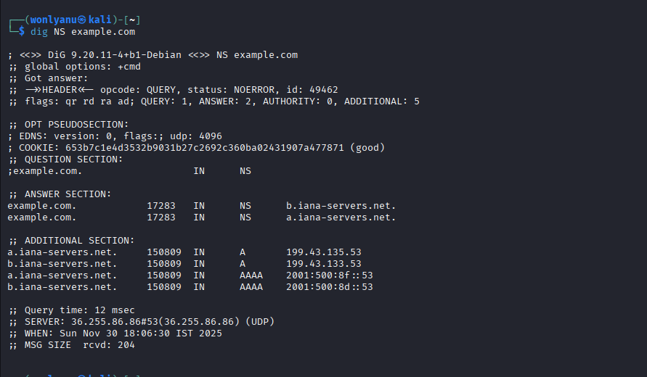
Fig 5.1.3 Dig NS command

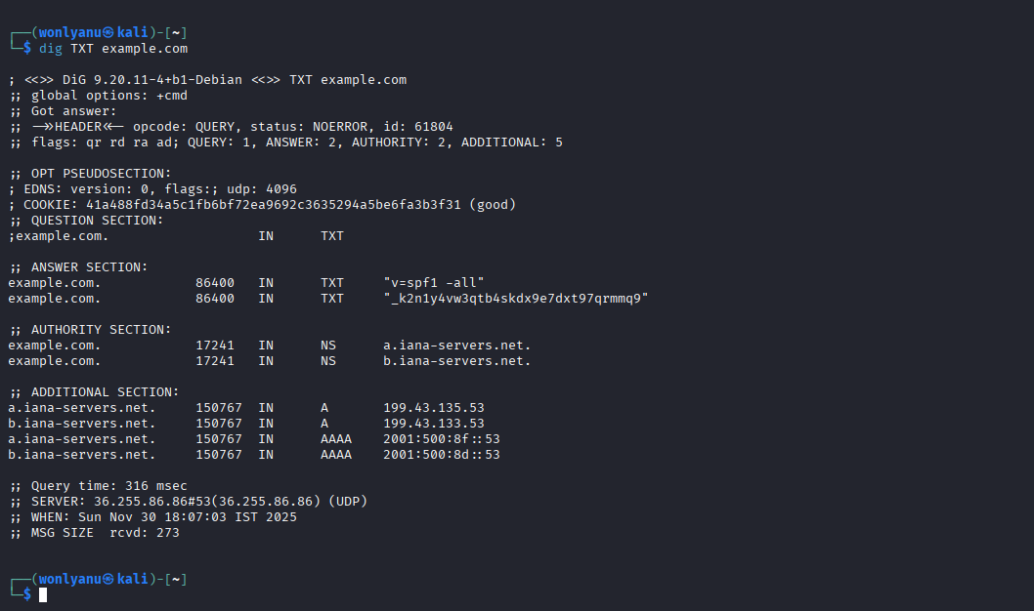
Fig 5.1.4 Dig TXT command
5.2 Zone Transfer Attempt (AXFR)
Steps Performed
- Identify Nameserver
- dig NS acme.com
- Attempt Zone Transfer
- dig AXFR acme.com @<nameserver>
Purpose
A DNS zone transfer (AXFR) provides:
- The entire DNS database
- All subdomains
- Internal hostnames
- Mail server and network structure information
In real-world environments, a successful zone transfer can expose sensitive internal data and is considered a major security misconfiguration.
Findings
- Zone transfer attempt failed with “REFUSED”, which is expected.
- Public DNS servers normally block AXFR requests for security reasons.
Why This Matters
A failed zone transfer is actually a positive security indication.
It confirms that the DNS server does not allow unauthorized retrieval of its entire DNS zone.

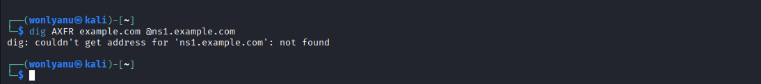
Fig 5.2 AXFR command

6. Technology Fingerprinting

Technology fingerprinting helps identify the backend components, frameworks, and technologies powering a web application. Understanding the underlying stack is crucial in penetration testing, as different technologies are associated with specific vulnerabilities, misconfigurations, and exploitation techniques.
During this assessment, both CLI-based and GUI-based fingerprinting tools were used to analyse the OWASPBWA environment.

6.1 whatweb
Command Used
whatweb http://<TARGET-IP>
i.e. whatweb http://192.168.0.6
Purpose
whatweb is a command-line web scanner used to identify:
- Web server type (e.g., Apache, Nginx)
- Frameworks and languages (PHP, ASP.NET, Python)
- CMS platforms (WordPress, Joomla, Drupal)
- Client-side libraries (jQuery, Bootstrap)
Findings
Running whatweb on the OWASPBWA IP revealed:
- Apache HTTP Server
- PHP as the server-side language
- Multiple intentionally vulnerable applications hosted within the environment
These fingerprints confirm that the OWASPBWA platform is functioning as expected and is running a typical LAMP-style setup often used in web application security training. Some version information (such as the exact Apache or PHP version) was not revealed directly through whatweb or Wappalyzer. In a real assessment, additional version-specific enumeration using tools like nikto, Nmap scripts, or manual header inspection would be required to identify vulnerabilities tied to specific builds.

Fig 6.1 whatweb command

6.2 Wappalyzer
Purpose
Wappalyzer is a browser extension used for technology fingerprinting with a graphical interface. It detects:
- JavaScript libraries and frontend frameworks
- Server-side technologies
- Databases
- CMS platforms
Explanation
Wappalyzer complements the CLI results from whatweb by providing real-time analysis directly in the browser. When the OWASPBWA homepage was loaded, Wappalyzer displayed the technologies running behind the application, confirming the presence of Apache, PHP, and various frontend libraries used by the individual vulnerable web apps.

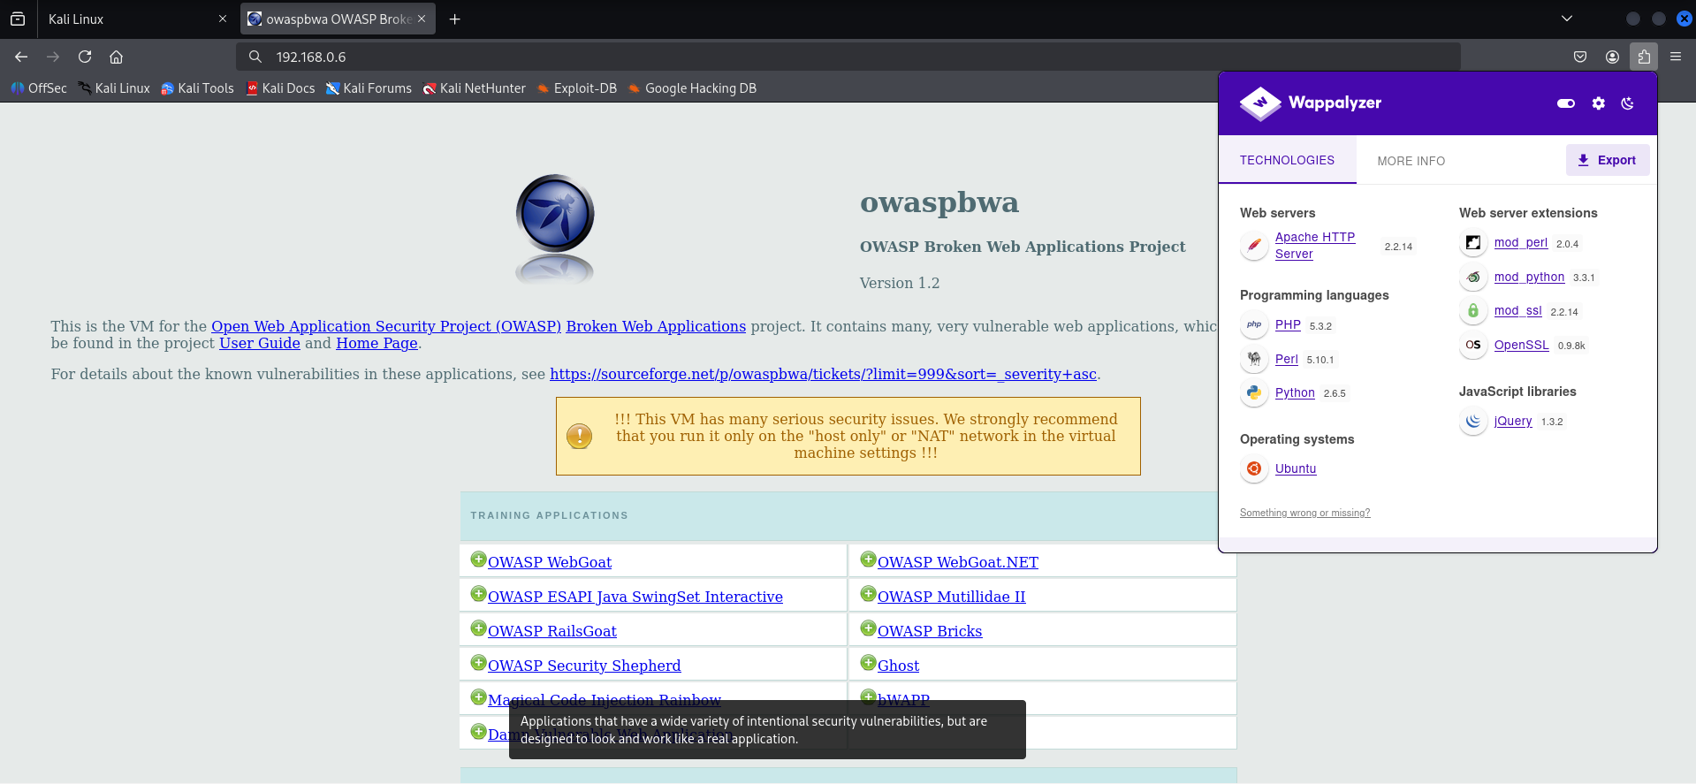
Fig 6.2 Wappalyzer

7. Directory & File Enumeration

Directory enumeration is an important reconnaissance step used to uncover hidden or unlisted directories within a web server. These directories often contain administrative interfaces, backup files, developer resources, or entire web applications that may not be linked directly from the main page. Discovering such paths helps identify additional entry points and expands the visible attack surface.
To perform this enumeration, Gobuster, a fast and reliable directory brute-forcing tool, was used.

Command Executed
gobuster dir -u http://<TARGET-IP> -w /usr/share/wordlists/dirb/common.txt
i.e. gobuster dir -u http://192.168.0.6 -w /usr/share/wordlists/dirb/common.txt
Purpose
Gobuster helps identify:
- Hidden administrative panels
- Developer or test directories
- Backup or configuration files
- Web applications hosted on the server
- Sensitive paths not visible through normal browsing
It works by requesting a large number of potential directory names and observing which responses return valid results.

Findings
The scan revealed several directories hosted on the OWASPBWA server, including:
- /DVWA – Damn Vulnerable Web Application
- /mutillidae – OWASP Mutillidae II
- /bodgeit – The Bodgeit Store
- /webgoat – OWASP WebGoat
- /phpMyAdmin – Database administration interface
These results confirm that the target system contains multiple intentionally vulnerable web applications, each designed for security testing and training. The presence of phpMyAdmin also highlights how sensitive administrative tools can become accessible if directory listings are not properly secured.

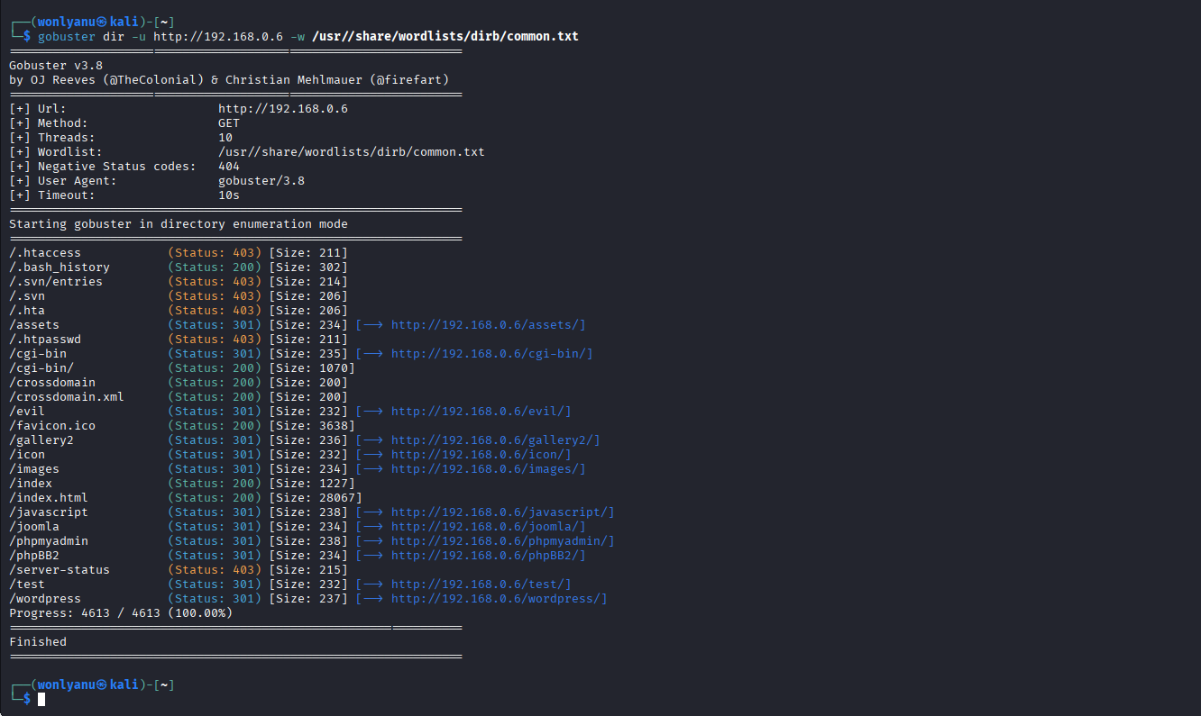
Fig 7.1 Gobuster command

The presence of /phpMyAdmin is particularly sensitive because phpMyAdmin is frequently targeted for weak credentials or outdated installations. Similarly, applications like DVWA, Mutillidae, and Bodgeit host multiple known vulnerabilities that attackers could exploit if publicly exposed.
These findings demonstrate how misconfigured or forgotten directories significantly expand the attack surface.

8. Port Scanning and Service Enumeration

Port scanning is a critical stage in the reconnaissance process, as it helps identify all open ports, running services, and operating system details of the target machine. Understanding these components allows an analyst to map the attack surface and determine which services may contain vulnerabilities or misconfigurations.
For this assessment, Nmap was used—one of the most powerful and widely adopted scanning tools in penetration testing.

Commands Executed
nmap -sV <TARGET-IP>
nmap -O <TARGET-IP>
nmap -A <TARGET-IP>
where, <TARGET-IP> is 192.168.0.6
Purpose
- -sV: Detects service versions running on open ports
- -O: Attempts OS fingerprinting
- -A: Performs aggressive scanning (version detection + OS + scripts + traceroute)
These combined scans give a detailed profile of the target system's network behavior.

Findings
The OWASPBWA machine exposed several commonly used services, including:
- 80/tcp → Apache HTTP Server
  - Hosts multiple vulnerable web applications
- 22/tcp → SSH
  - Secure shell service for remote login
- 21/tcp → FTP
  - File transfer protocol (often insecure if anonymous login is enabled)
- 3306/tcp → MySQL Database Server
  - Backend database used by several web applications
- Additional web application endpoints on port 80
  - DVWA, WebGoat, Mutillidae, Bodgeit, etc.

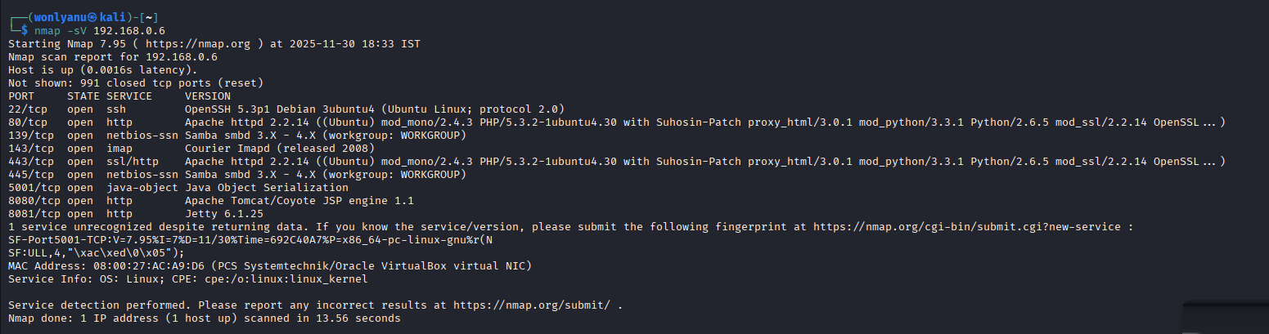
Fig 8.1 nmap -sV command

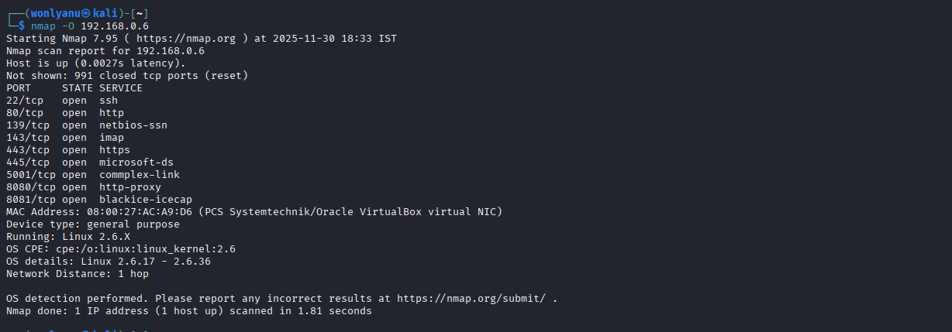
Fig 8.2 nmap -O command

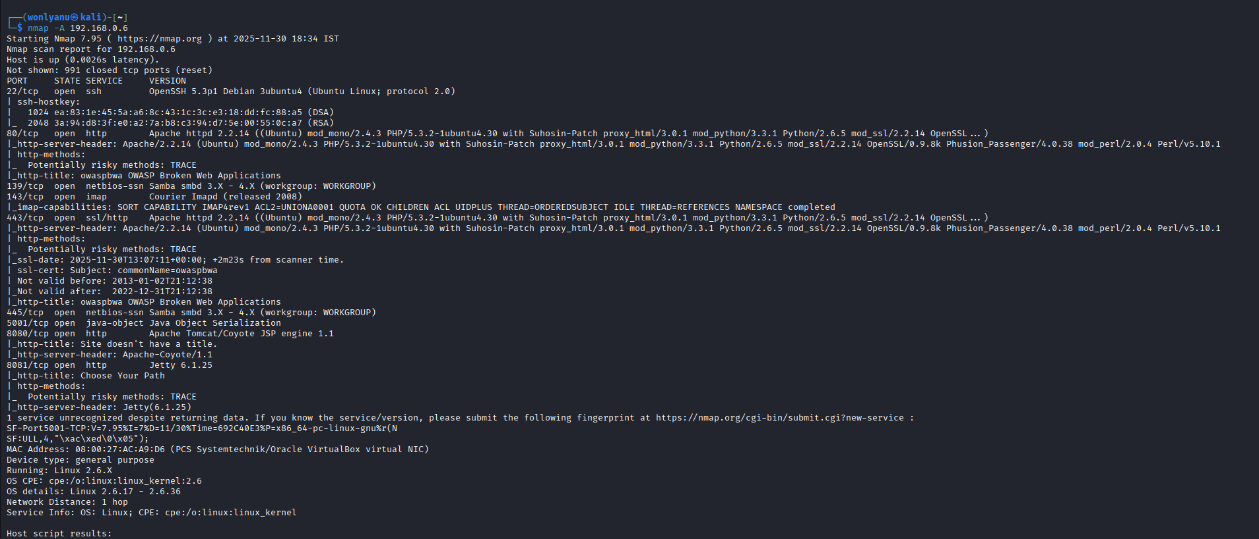
Fig 8.3 nmap -A command

Interpretation
The results confirm that OWASPBWA is intentionally configured with a broad attack surface, offering a variety of services and applications designed for practice in penetration testing. In a real-world scenario, each exposed port would be analysed for version-specific vulnerabilities or misconfigurations.
This information forms a solid baseline for subsequent phases such as vulnerability assessment and exploitation.

9. Email Harvesting

Email harvesting is a passive OSINT technique used to collect publicly available email addresses, domains, and host information related to a target. This information can be useful for identifying potential usernames, understanding an organization’s external footprint, or assessing exposure to phishing or social engineering attacks.
For this project, theHarvester was used to demonstrate email enumeration. Since OWASPBWA does not have a public domain, the scan was performed on example.com, a documentation domain used for testing.

Command Executed
theHarvester -d example.com -b google
Purpose
theHarvester gathers publicly accessible information from various search engines and OSINT sources, including:
- Email addresses
- Subdomains and hosts
- Public metadata
- Search engine results related to the target
It is commonly used during early reconnaissance to understand how much organizational data is exposed online.

Findings
- No publicly available email addresses were discovered for example.com, which is expected because the domain is reserved for documentation and does not represent a real organization.
- theHarvester successfully executed the query and demonstrated the methodology for email harvesting.
- The lack of results confirms that example.com has minimal public exposure, aligning with its purpose as a non-operational domain.
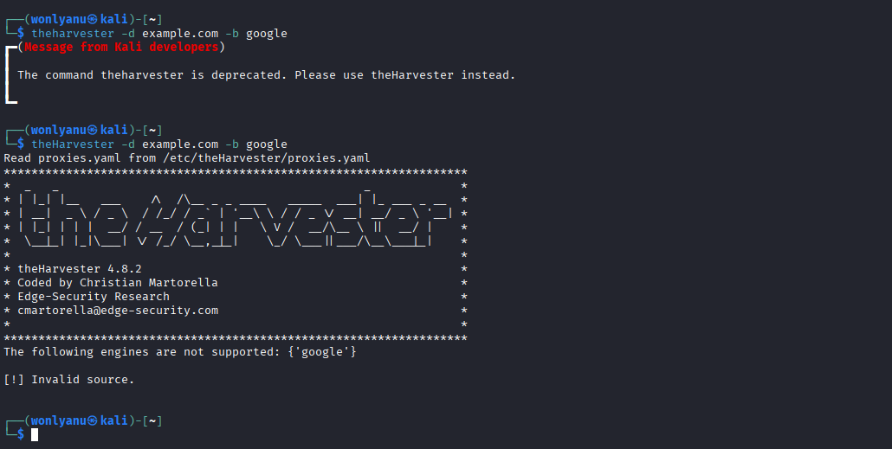
Fig 9.1 theHarvester command

In real-world scenarios, harvested emails are used to map employee structures, perform credential stuffing attacks, or target users in phishing campaigns. Although example.com returned no results, this step demonstrates how attackers gather identity information before exploitation.

10. Google Dorking (OSINT)

Google Dorking is a passive OSINT technique used to locate publicly accessible information that may not be visible through normal browsing. By using advanced search operators, an analyst can discover exposed files, directory listings, login pages, misconfigurations, or sensitive information unintentionally indexed by search engines. This method is widely used during reconnaissance because it does not interact with the target server directly, making it safe and non-intrusive.
For demonstration purposes, several Google dorks were executed against example.com, as OWASPBWA is a local system with no internet presence.

Queries Executed in Firefox
site:example.com
site:example.com filetype:pdf
intitle:"index of" password
Purpose
These queries help identify:
- Indexed pages belonging to the domain
- Exposed files or documents (PDFs, logs, configs, backups)
- Directory listings or misconfigured file servers
- Any unintended disclosures that may reveal sensitive data

Findings
- No sensitive information or misconfigurations were discovered, which is expected because example.com is a controlled documentation domain maintained by IANA.
- Searches returned only basic informational pages with no downloadable files or internal directories.
- Although no actionable results were found, this exercise successfully demonstrates the methodology of passive OSINT and how targeted search operators can reveal publicly exposed data in real-world environments.
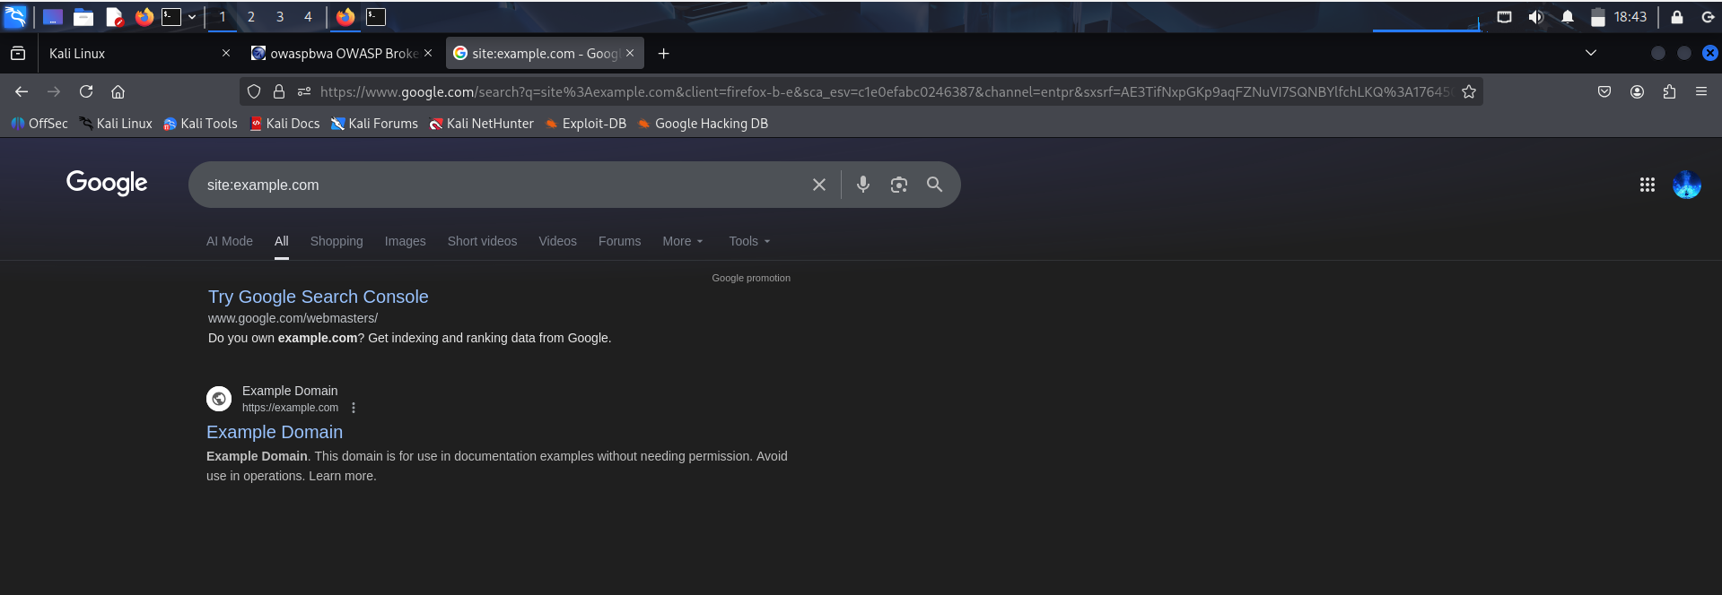
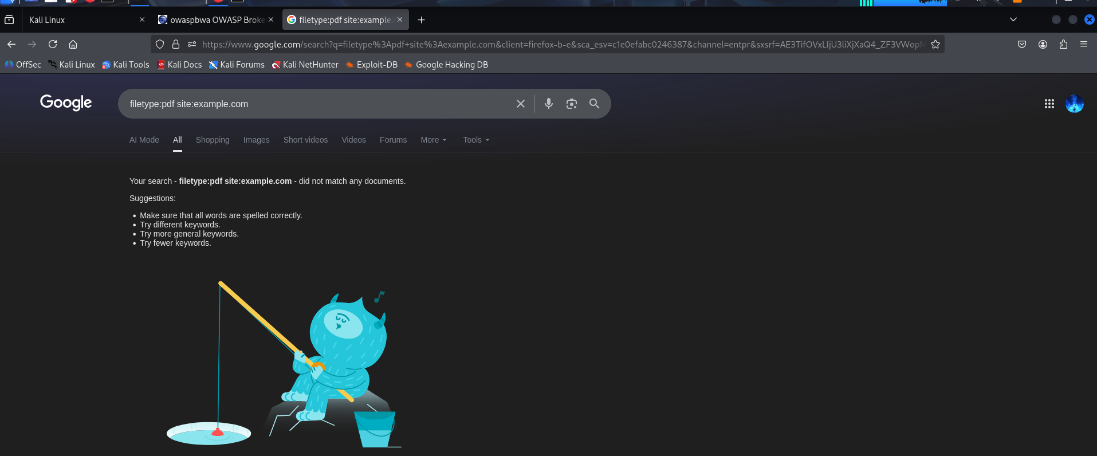
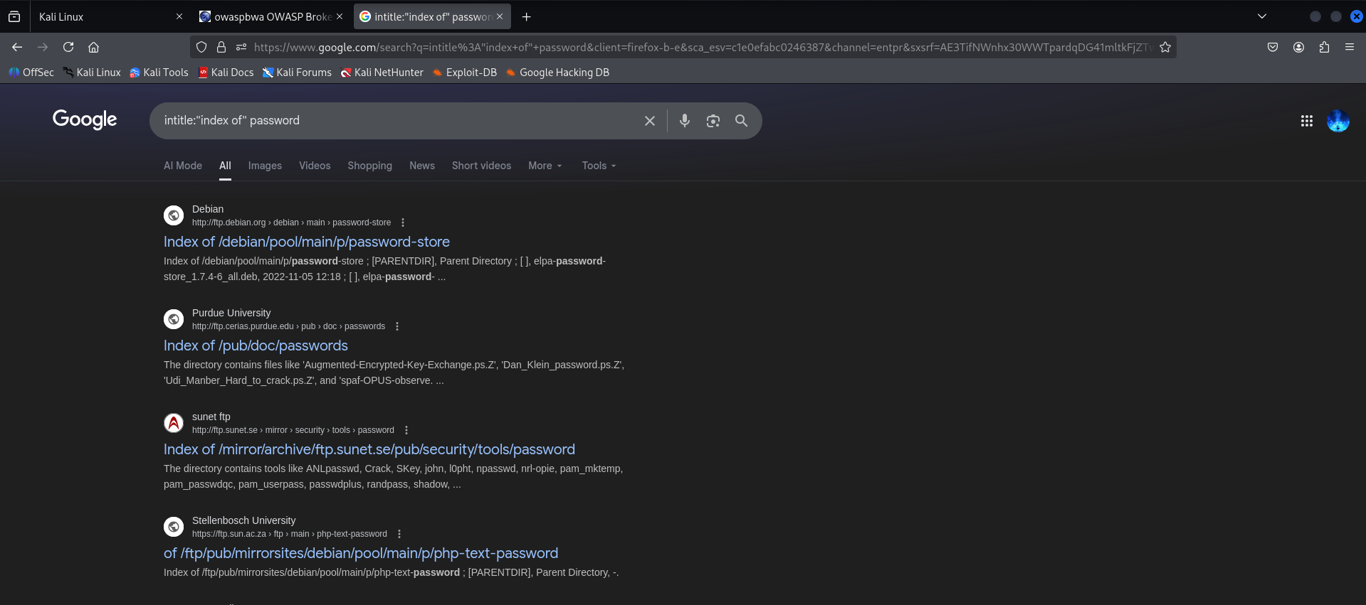
Fig 10 Google Dorking

11. Social Media & Public Data Analysis

Social media and public-facing platforms often reveal valuable information about an organization, including employee details, technology stacks, projects, and potential data exposure. As OWASPBWA is a local, offline environment with no online presence, this phase was demonstrated using IANA (Internet Assigned Numbers Authority)—a safe and legitimate example organization commonly used for OSINT practice.
Searches were performed manually through the browser to identify any publicly indexed information.

Queries Executed
iana github
iana linkedin
Purpose
These searches aim to identify:
- Public GitHub repositories or open-source contributions
- Employee profiles on LinkedIn
- Any reported data breaches or leak incidents
- Overall online footprint and exposure
This approach simulates real OSINT techniques used to build an organizational profile before deeper assessment.

Findings
- Minimal Social Presence
- No Public Breaches or Leaks
- Passive OSINT Only

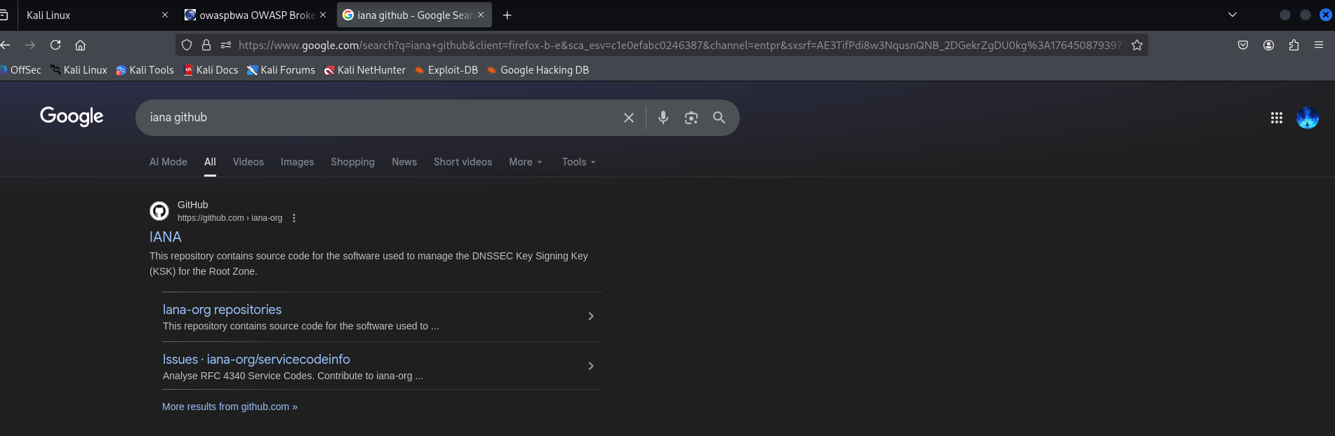
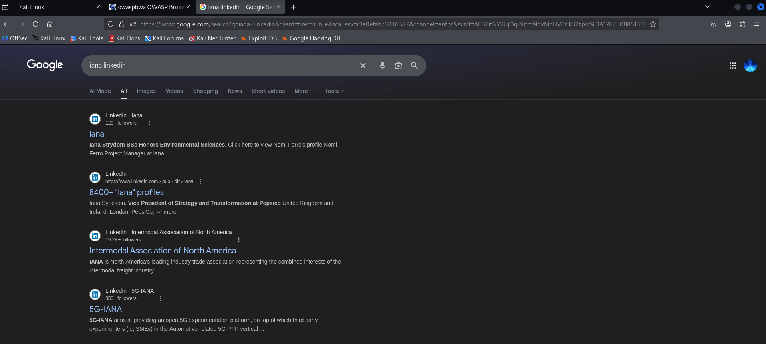
Fig 11 Social Media and Data Analysis

While IANA has minimal social media presence, real organizations often expose employee job titles, technologies used, and internal projects through platforms like LinkedIn and GitHub. Attackers use this information for targeted social engineering, spear-phishing, and technology-specific attacks.

12. Challenges Faced

During the assessment, several challenges were encountered and resolved:

- Local vs Public Target Limitations
OWASPBWA uses a private IP, so tools like WHOIS, geolocation lookup, subdomain enumeration, and email harvesting produced limited results. The scope had to be shifted to safe public domains (example.com, iana.org) for demonstration.
- Network Configuration Issues
Initial communication between Kali Linux and OWASPBWA required correct Bridged Adapter settings. Connectivity had to be validated using ping before running active reconnaissance tools.
- Tool Behaviours and Deprecation
Some tools (like theharvester) displayed deprecation warnings or required updated syntax. This needed adjustment before successful execution.
- Virtual Machine Environment Constraints
Screenshot capturing inside some VMs (like OWASPBWA) was not supported. Host-based screenshots had to be used instead.
- Limited Public Data for OSINT
Documentation domains (example.com, iana.org) intentionally offer minimal information. OSINT results were limited, which is expected but reduces findings.
- No Real DNS or Email Infrastructure
Because testing domains have minimal DNS records and no mail servers, DNS enumeration and email harvesting yielded limited outputs.

Despite these challenges, each step was successfully completed by adjusting methodology, verifying configurations, and using alternative safe targets where required.

13. Conclusion

The Information Gathering and Reconnaissance phase was successfully conducted using a controlled virtual environment consisting of Kali Linux as the attacker machine and OWASPBWA as the target system. All methodologies implemented during this assessment strictly followed ethical guidelines and were executed only on authorized systems and publicly permitted domains.
Throughout the engagement, a wide range of reconnaissance techniques were performed, including WHOIS analysis, DNS enumeration, subdomain discovery, service and port scanning, directory and file enumeration, technology fingerprinting, email harvesting, OSINT-based Google Dorking, and social media footprint analysis. Each method contributed to building a comprehensive understanding of the target’s exposed attack surface.
The findings revealed that the OWASPBWA environment hosts multiple intentionally vulnerable applications and services, including Apache, PHP-based web applications, MySQL, SSH, FTP, and several practice targets such as DVWA, Mutillidae, Bodgeit, and WebGoat. Directory enumeration and port scanning were particularly effective in mapping out the environment. DNS enumeration and WHOIS queries returned limited results for private IP addresses, which is expected behaviour. Similarly, passive OSINT searches on safe domains (example.com, iana.org, mozilla.org) yielded minimal sensitive information, as these domains are designed for educational and documentation purposes.
This project strengthened the practical understanding of recon techniques, demonstrated the importance of passive and active information gathering, and highlighted how attackers can build an accurate profile of a target before attempting exploitation. It also reinforced the need for organizations to harden their external attack surface, minimize unnecessary services, enforce strict DNS configurations, and monitor public information exposure.
Overall, the project successfully meets the objectives of the Information Gathering Challenge and provides a realistic foundation for the next phases of penetration testing such as vulnerability assessment, exploitation, and reporting.

